How to classify handwritten digits??

For example, many ATM’s have an automated scanner to cash personal checks. This scanner will read the (handwritten) value on the check and deposit that amount in your account. How does the ATM read everyone’s different handwriting and get the check amount correct?

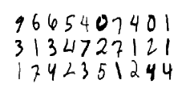
The goal in this Case Study data analysis project is to take an image of a handwritten single digit, and determine what that digit is. The data needs to be able to determine the digit, without needing the eye of a human being.
The data for this project were gathered from the MNIST dataset. The MNIST ("Modified National Institute of Standards and Technology") dataset is a classic within the Machine Learning community that has been extensively studied. More detail about the dataset, including Machine Learning algorithms that have been tried on it and their levels of success, can be found at http://yann.lecun.com/exdb/mnist/index.html.

Data Files: train.csv, test.csv
The data files “train.csv” and “test.csv” contain gray-scale images of hand-drawn digits, from zero through nine.
Each image is 28 pixels in height and 28 pixels in width, for a total of 784 pixels in total. Each pixel has a single pixel-value associated with it, indicating the lightness or darkness of that pixel, with higher numbers meaning darker. This pixel-value is an integer between 0 and 255, inclusive.
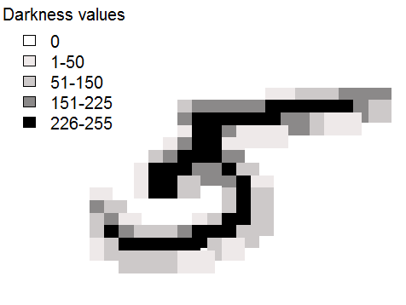
Figure 1: An example of a handwritten digit from the MNIST dataset.
The training data set, (train.csv), has 785 columns. The first column, called "label", is the digit that was drawn by the user. The rest of the columns contain the pixel-values of the associated image.
Each pixel column in the training set has a name like pixelx, where x is an integer between 0 and 783, inclusive. To locate this pixel on the image, suppose that we have decomposed x as x = i * 28 + j, where i and j are integers between 0 and 27, inclusive. Then pixelx is located on row i and column j of a 28 x 28 matrix, (indexing by zero).
For example, pixel31 indicates the pixel that is in the fourth column from the left, and the second row from the top, as in the ascii-diagram below.
Visually, if we omit the "pixel" prefix, the pixels make up the image like this:
000 001 002 003 ... 026 027
028 029 030 031 ... 054 055
056 057 058 059 ... 082 083
| | | | ... | |
728 729 730 731 ... 754 755
756 757 758 759 ... 782 783
The test data set, (test.csv), is the same as the training set, except that it does not contain the "label" column.

Goals and Objectives:
You will be given R commands (already written) that you will need to run in R. The commands will show you how to manipulate this data set, do some descriptive statistics, and interesting data visualizations. You will need to carefully study the R commands to understand the purpose of each line of code. At the end of the module, I will turn the project over to you for further analysis.
The evaluation for this project will be the accuracy and thoroughness of the R command descriptions. You must demonstrate complete understanding of the given codes and be able to further the analysis on your own.

